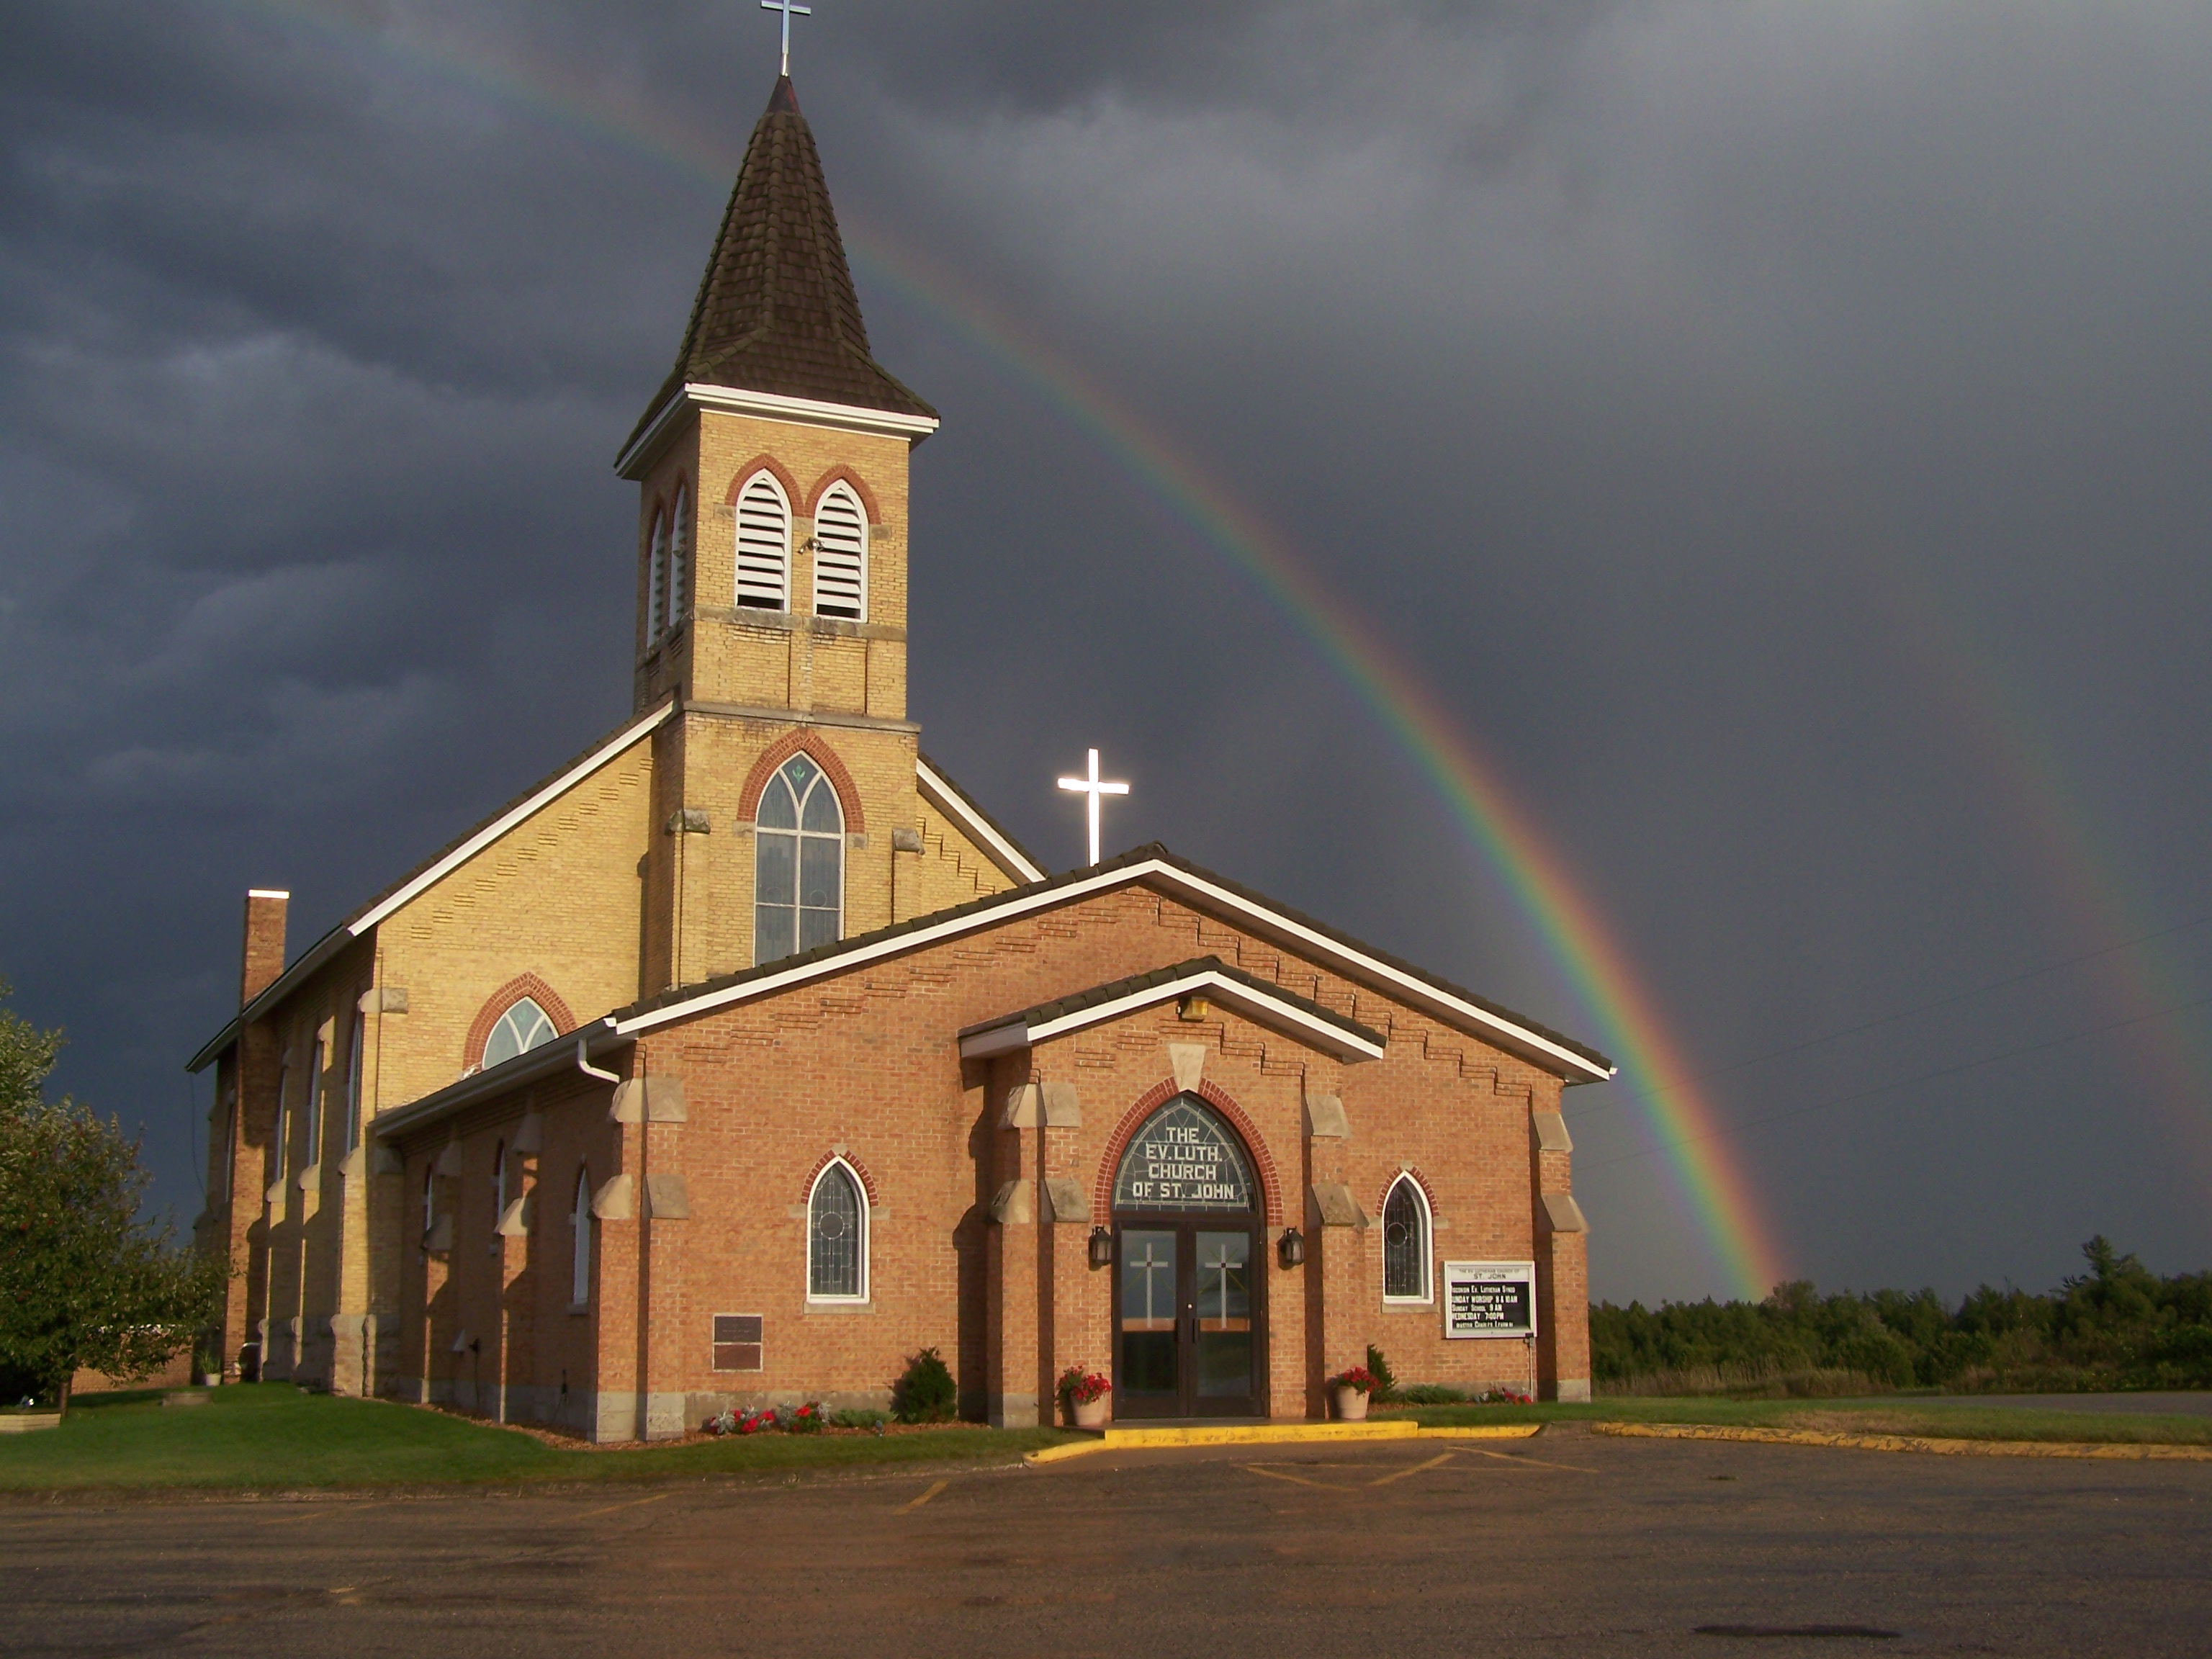
The Evangelical Lutheran Church of St. John
N1916 Church Road
Peshtigo, Wisconsin 54157-9673
Pastor Sargent 920-228-1061

06/25/2020
Dear members of St. John,
Many of us are watching. We see what is happening around us. People struggle, fear, and worry, some retreat, others try to isolate themselves from it all. Are you frustrated, angry or feel hopeless? This is when the placards start to show up. The spray-painted words over the other graffiti. LOVE. Yes, the very protester’s and rioters lift up the signs. And the chat begins with the refrain from that famous Beatle song. “All we need is love, love, all we need is love. Altogether now. All we need is love.” Seems to be the right answer. Yes, we need love. It will cover over all this hate. God’s love!
Sunday the 28th of June will be the Fourth Sunday after Pentecost. We are still asking people to sign up for services.
Worship

- There will be two services on Sunday at 8:30 and 10:00.
- We will worship with no more than 100 people in attendance for each service.
- Please register for a specific service with the following links.

https://www.signupgenius.com/go/30E0E4FACAA2AA0F85-8304

https://www.signupgenius.com/go/30E0E4FACAA2AA0F85-10003

If you do not have internet access, please register by phone with Pastor Sargent at 920-228-1061.

- We will have portions of the church pews partitioned off to accommodate social distancing. Please be sure to sit only in the apportioned sections. Ushers will guide you to your seat of choice.
- No hymnals will be used. All service materials will be printed in the church bulletin, handed out to each member by an usher wearing a mask and gloves.
- We will not be passing offering plates in the worship service but will have them at the doors of the sanctuary where you may drop your offering.
- When church is over you will be ushered out. Please don’t get up and leave on your own. That will make it difficult to keep proper social distancing.
- We are not requiring that everyone wear a facemask, but please remember social distancing. If you feel comfortable wearing one, we encourage you to do so. Ushers will be wearing them.
Social Interaction

In order to maintain responsible social distancing, we are strongly encouraging the following:
- No physical contact: handshakes, hugs, fist bumps, etc.
- No gathering within church for socializing either before or after services.
- At this time all other church events, Bible Study, Sunday School, Ladies Aid and Quilting (etc.) will be on hold.

- If you are not feeling well or have concerns about your own health, you do not need to attend. We will continue with the Livestreaming service at 8:30. If you would like to receive private communion at home please contact Pastor Sargent.
These guidelines help us to be able to gather together at this time. If we all are willing to sacrifice for the good of those around us, we can make this work. Please, in all this, show patience and kindness to your brothers and sisters.


Reminder of Important Information:

- The Quarterly Voters meeting and open Forum will be held on Sunday the 28th June, following the 10:00 service. In keeping with our guidelines for meeting, we will not be able to have more than 100 at the open Forum and voters meeting. If you are not able to attend and have an item or concern to bring to the meeting, please share it with a Council member or Pastor.

Pastor Daniel Sargent

